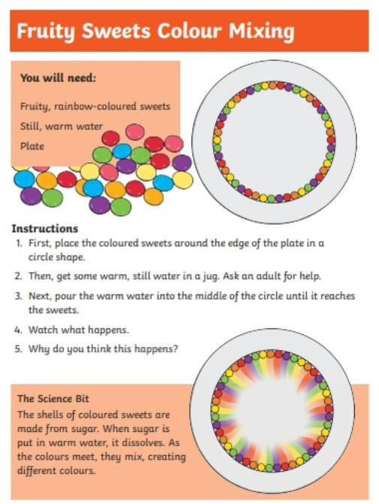
R.E. – Watch and listen to the story of Rama and Sita.
https://www.bbc.co.uk/programmes/articles/1pYRg2f202rqWHrp3ywhTyX/religions-of-the-world
What did you learn from the story?
Is it better to work alone or as a team?
Think of some different activities where we work better as a team. You may want to draw or write about these in your home learning book. We can’t wait to see what you have come up with!
