WEEK 6 W/C May 4th Class 5W Mrs Williams
ENGLISH – writing and comprehension Vocabulary of WWII
HISTORY ART
World War 2 Victory in Europe 75 years anniversary May 8th
English Pie Corbett story The Tunnel – Evacuee story with writing ideas
Powerpoints VE Day - write a postcard about how you think the people described in the powerpoint might celebrate
VE day comprehension
VE day colourings – flags- service men – children – make a Spitfire
Decorate your windows on May 8th
Crack the code use Morse code to write a message
WELLBEING & MENTAL HEALTH
Watch the powerpoint with your carer and look at the two activities

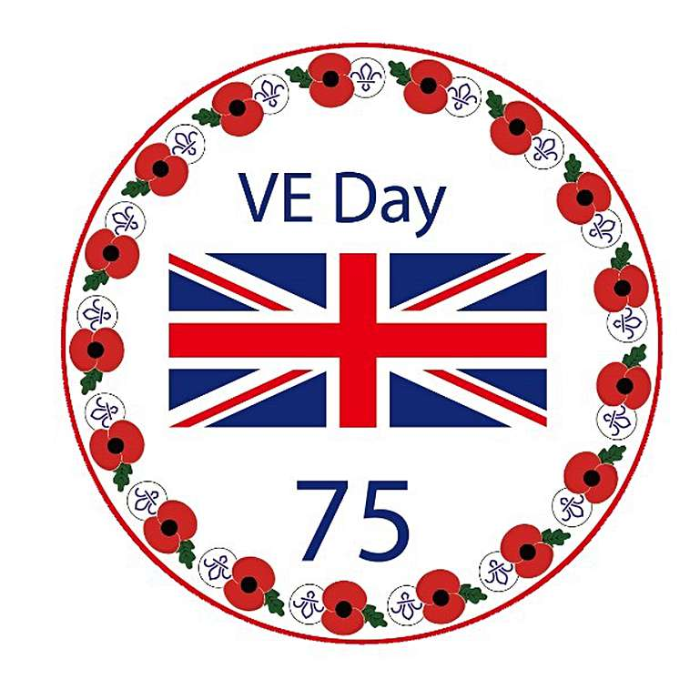Make this with a paper plate

