Converting between metric and imperial units
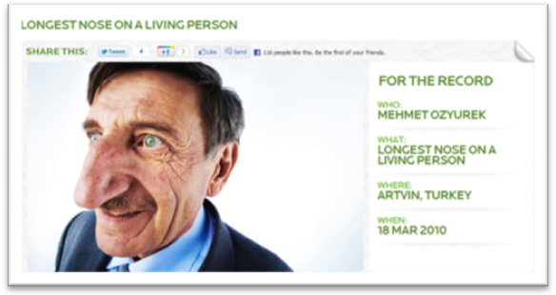
Give answers to 1 decimal place.

1. a) Convert 12.5cm to inches.
b) Convert 6cm to inches.
c) The longest nose on a living person is 8.8cm. Convert this measurement to inches.
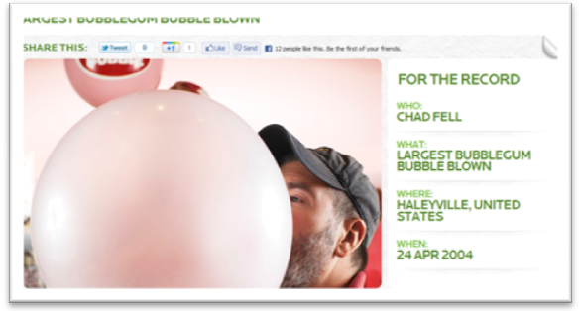
2. a) The largest bubblegum bubble blown has a diameter of 20.3 inches. Convert this measurement to centimetres.
b) Convert 14 inches to centimetres.
c) Convert 7.4 inches to centimetres.
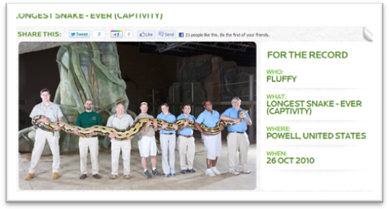
3. a) Convert 51cm into feet.
b) The longest snake ever is 7.3m. Convert this measurement to feet. (Hint: convert 7.3m to centimetres first, then into feet)
c) Convert 6.5 feet into (i) cm (ii) m.

4. Convert the following into litres: a) 4 pints b) 3 gallons
5. Convert the following into pints: a) 855 ml b) 7l
6. Convert the following into kilograms: a) 4.4 pounds b) 1 stone
7. Convert the following into kilometres: a) 9 miles b) 16.5 miles
8. Extension question
I run a 10km race in 56 minutes. What is my average speed for the race in:
a) kilometres per minute b) miles per minute c) miles per hour
Answers
1. a) 12.5cm / 2.5 = 5 inches
b) 6cm / 2.5 = 2.4 inches
c) 8.8cm / 2.5 = 3.52 = 3.5 inches (1 dp)

2. a) 20.3 inches x 2.5 = 50.75 = 50.8cm (1 dp)
b) 14 inches x 2.5 = 35cm
c) 7.4 inches x 2.5 = 18.5cm

3. a) 51cm / 30 = 1.7 feet
b) 7.3m = 730cm. 730 / 30 = 24.33333…. = 24.3 feet (1 dp)
c) (i) 6.5 feet x 30 = 195cm
(ii)195 / 100 = 1.95m

4. a) 4 pints / 1.75 = 2.285714…. = 2.3 litres (1 dp)
b) 3 gallons x 4.5 = 13.5 litres

5. a) 855ml / 570 = 1.5 pints
b) 7l x 1.75 = 12.25 pints

6. a) 4.4 pounds / 2.2 = 2 kg
b) 1 stone = 14 pounds. 14 / 2.2 = 6.36363636… = 6.4 kg (1 dp)

7. a) 9miles x 1.6 = 14.4 km
b) 16.5 miles x 1.6 = 26.4 km

8. a) 10km / 56 minutes = 0.1785714… = 0.2 km per minute
b) 10 km / 1.6 = 6.25 miles. 6.25 miles / 56 minutes = 0.11160714… = 0.1 miles per minute
c) 60 mins in 1 hour. 0.11160714… x 60 = 6.69642857…. = 6.7 miles per hour

