Name __________________________ Date ______________
am times | pm times
morning hours | afternoon hours
midnight noon midnight

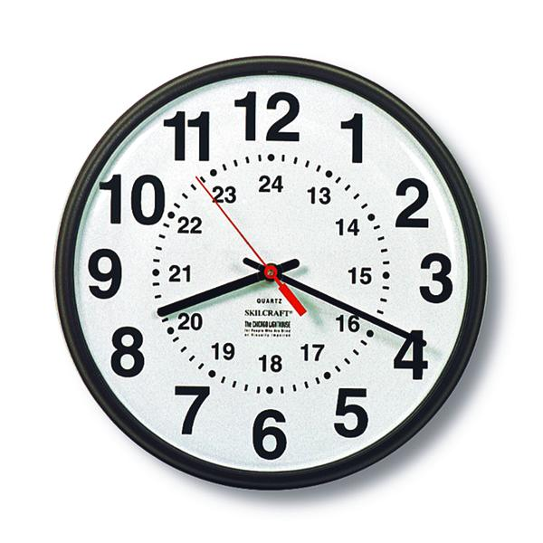
Time


Cut and stick the above box in your numeracy book after completing the following questions:
Join the matching times:
10:25
11.10 pm
1.
18:30
6.15 pm
2.

3.
23:10
10.25 am

4.
06:15
12.45 am

5.
00:45
6.30 pm

Write each time in the 24-hour clock time:
4.30 pm

6.
6.25 pm

7.
5.15 pm

8.

9.
10.20 am

10.
11.55 pm

