Queen Victoria
- Choose the correct word or date from the brackets to fill in each gap:

Victoria was born on 24th May ............................................ (1819 / 1066 / 1939)
Her uncle King William IV had no children, so Victoria would become queen when he died.

Victoria was twelve years old when she was told she might become the next ............................................. (princess / queen / duchess)
When she was ............................................ (8 / 18 / 28) her uncle died and she became the Queen of ............................................. (Britain / Africa / America)
This was in ............................................. (1800 / 1900 / 1837)

Victoria married ............................................ (Andrew / Arthur / Albert)
They had ............................................ (8 / 9 / 10) children, four boys and five girls. When Albert died Queen Victoria was very ............................................. (happy / sad / excited)

On June 22nd 1897 people were given a special holiday to celebrate the Queen’s ............................................ (silver / golden / diamond) jubilee. People from all over Britain came to London to celebrate her ............................................ (25 / 50 / 60) years as Queen.

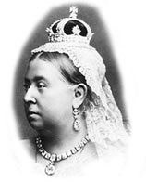
Queen Victoria died in ............................................ (1901 / 1910 / 1991) She was ............................................ (62 / 72 / 82) years old. She was buried beside her husband at Windsor Castle.

Now you know all about my life!

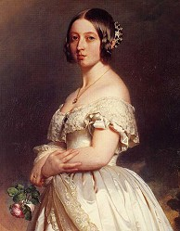
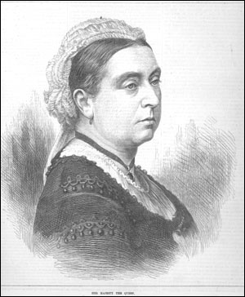
2
1

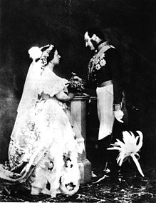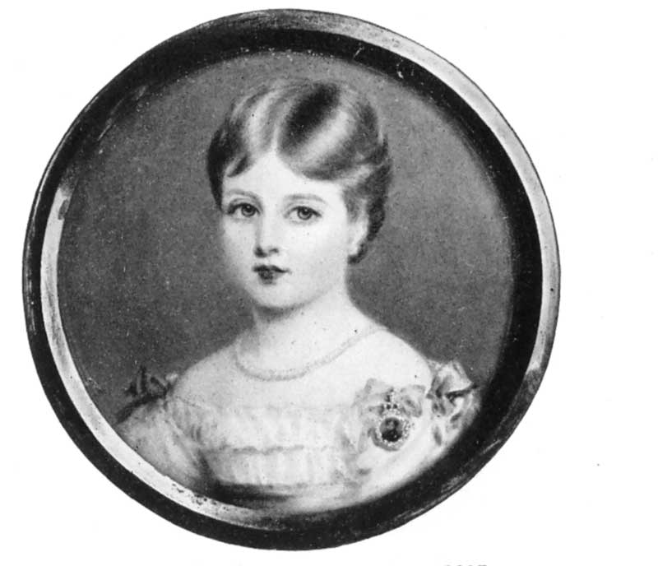
4
3

Write the number of the correct photo next to each piece of information:

Princess Victoria in 1827.
Queen Victoria in 1897.
Princess Victoria in 1837.
Queen Victoria in 1840.
She is 78 years old.
She is 21 years old.
She is 18 years old.
She is 8 years old.

Victoria becomes Queen.
She lives in Kensington palace and is escorted everywhere.
She is wearing black because she is a widow. Albert dies in 1861.
She is marrying Albert.

