ALL ABOUT BEES 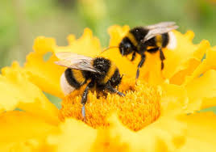
Science and English writing
This week we are looking at how important to the life cycle of plants the bee is.
- As one of the important pollinatators some plants rely on insects for their reproduction. You will find a help sheet to help you write a persuasive magazine article trying to persuade your reader of the importance of caring for our bees. How can we do this ? Your report should be written and organised in paragraph for each point.
- Design a poster with a slogan asking people to BEE KIND to bees
- Science- Describe how pollination happens in flowering plant- use diagrams which are labelled
- Complete the parts of a flower and bees worksheet
- Produce a bees Fact File – research Bees- different types of bees- life cycle of a bee- how do bees make honey- how can we help bees- how do bees make a home – what is a worker bee, drone bee, queen bee ?

Watch this video
https://www.bbc.com/future/article/20140502-what-if-bees-went-extinct

