Rounding Decimal Numbers to One Decimal Place (1dp)
Example:
Round 3.46 to one decimal place
It is in between 3.4 and 3.5 : which is it closer to? 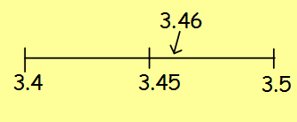
3.46 3.5 (1dp)

Just like with rounding to the nearest ten, hundred, thousand or whole number, if a number is exactly halfway, then we round up.
For example: 3.45 rounded to one decimal place would be 3.5
Exercise:
Round each of these numbers to one decimal place.
3.62 4.78 2.84 5.75

6.93 4.07 9.13 8.05

8.97 3.02 9.97 0.46

0.92 0.99 0.08 0.02

