Week 5
Monday
51
52
53
54
55
56
57
58
59
60 | sixty
61
62
63
64
65
66
67
68
69
70 | seventy
71
72
73
74
75
Can you write the word to match the number?
We have done for you.

Tuesday
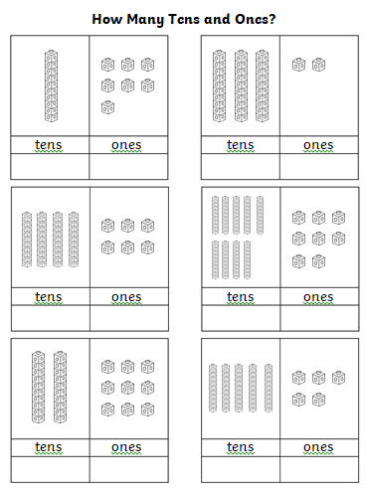

Wednesday
Missing Numbers
Fill in the missing numbers from these sections of hundred squares.

74 |  | 76
 | 85 |  | 87

 | 84 |  | 86
93 |  | 95

76
87
98

Thursday
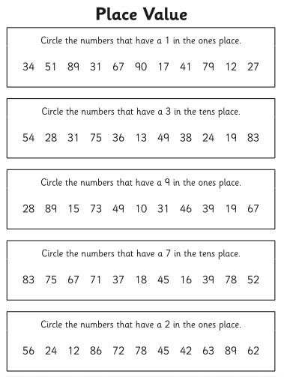

Thursday continued
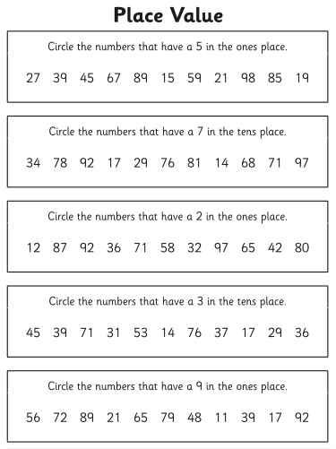
Friday

Counting in 5's
Complete the following sequences:
- 5 10 15 __ 25 __ f) __ 50 45 __ 35
- 35 30 __ 20 __ 10 g) 35 40 __ 50 __
- __ 25 30 35 __ 45 h) 65 __ __ 50 45
- 45 __ __ 30 25 20 i) __ __ 35 40 45

- 15 __ 25 30 __ 40 j) 75 70 __ __ 55

Complete the number square below:
1 | 2 | 3 | 4 |  | 6 | 7 | 8 | 9
11 | 12 | 13 | 14 |  | 16 | 17 | 18 | 19
21 | 22 | 23 | 24 |  | 26 | 27 | 28 | 29
31 | 32 | 33 | 34 |  | 36 | 37 | 38 | 39
41 | 42 | 43 | 44 |  | 46 | 47 | 48 | 49
51 | 52 | 53 | 54 |  | 56 | 57 | 58 | 59
61 | 62 | 63 | 64 |  | 66 | 67 | 68 | 69
71 | 72 | 73 | 74 |  | 76 | 77 | 78 | 79
81 | 82 | 83 | 84 |  | 86 | 87 | 88 | 89
91 | 92 | 93 | 94 |  | 96 | 97 | 98 | 99
Challenge:
When you count in 5’s, which numbers are odd and which are even?
What do you notice?

