C:\Users\Anna\AppData\Local\Microsoft\Windows\Temporary Internet Files\Content.IE5\Y0ZL2C00\MC900440424[1].wmf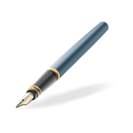C:\Users\Anna\AppData\Local\Microsoft\Windows\Temporary Internet Files\Content.IE5\Y0ZL2C00\MC900440424[1].wmf

road

boat

road



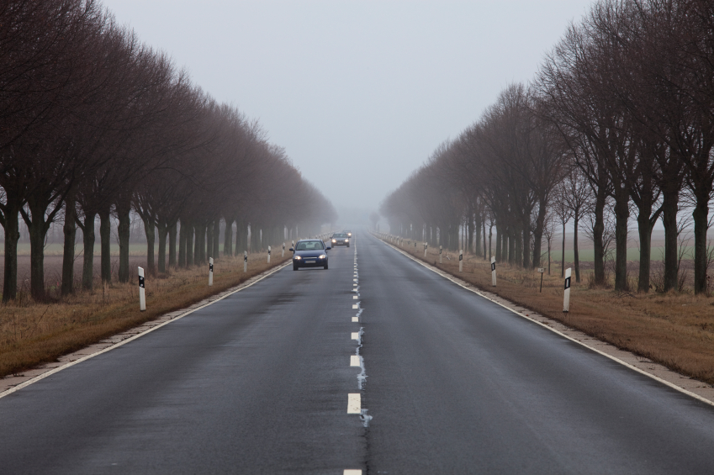

boat