Letters and Sounds
Parent Weekly Newsletter
Phase 3  New sounds this week | Tricky Words |  |  | Sounds already learnt
Phase 3  New sounds this week | was he they  are she her  my be me  all you |  |  | s a t p  i m n d  g o c k  ck e u r  h b f ff l ll ss | j v w x  y z zz qu  ch, sh, th, ng
ai | ee |  | igh |  | oa
ai as in rain | ee as in feet |  | igh as in light |  | oa as in goat
 |  |  | 
+ | 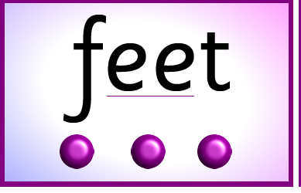 |  | 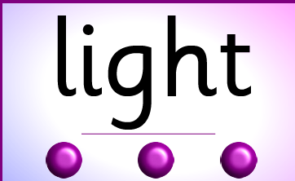 |  | 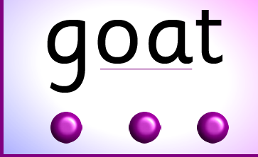
Words to Read anrain, bait, wait, Gail, pain, aim, sail, main, tail, see, weep, feel, feet, jeep, seem, meet, week, deep, keep, high, sigh, tight, might, night, right, sight, fight, tonight, coat, load, goat, loaf, road, soap, oak toad, foal, boatman |  | Write  rain, bait, wait, Gail, pain, aim, sail, main, tail, see, weep, feel, feet, jeep, seem, meet, week, deep, keep, high, sigh, tight, might, night, right, sight, fight, tonight, coat, load, goat, loaf, road, soap, oak toad, foal, boatman | 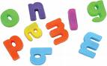Activities 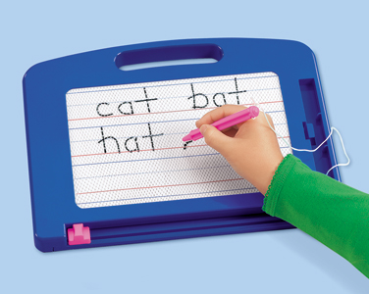  - Magnetic Letters  - Little whiteboards and pens, and magic boards  - Make your own flash cards (play snap, pairs,)  - Put sound buttons underneath the words
Internet Games

http://www.bbc.co.uk/schools/wordsandpictures/longvow/poems/fpoem.shtml

http://www.phonicsplay.co.uk/PictureMatch.html

http://www.phonicsplay.co.uk/BuriedTreasure2.html

