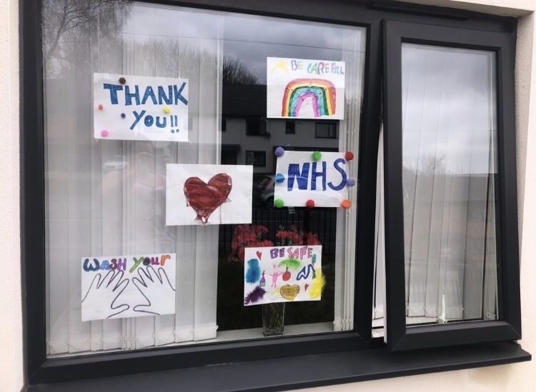
A fabulous looking front window sent in by one of our parents – thank you for sharing this! Miss Barker x

