ENGLISH - WRITING
This week – plan - write a draft copy - edit and improve then produce a best copy
Remember to organise your work into paragraphs
Use brackets, comma and dashes for parenthesis

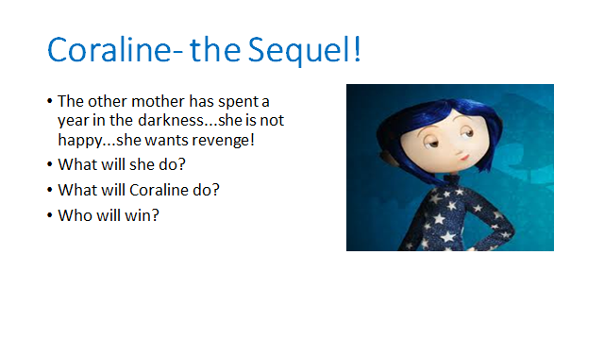IDEAS