Number Plate Challenge
Look at car number plates that pass by or are parked outside - how many different numbers can you make with the digits from the number plate by just rearranging the numbers? What’s the smallest number you can make? What’s the largest?

Now, using + - x and ÷ use the same licence plate numbers and again what’s the largest number you can make? What’s the smallest? You can use each number more than once.
Paper plane challenge
Make a paper plane then, flatten it out again and see how many triangles, rectangles, squares or other quadrilaterals you can see. Write the names on the shapes.

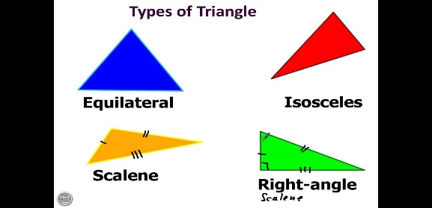

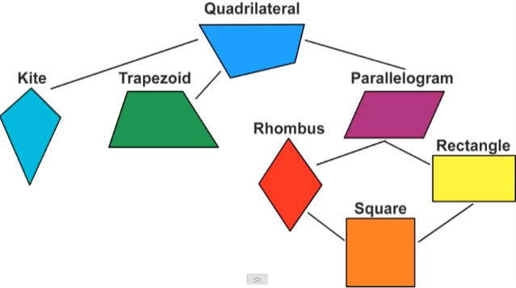

Circle challenge
Using a pencil, a piece of string or cotton or an elastic band and your finger (or another person’s finger) draw a perfect circle. You will obviously need help from another person with this one.
What is the mathematical name for the distance around the outside?
What is the mathematical name for the distance all the way across the circle? 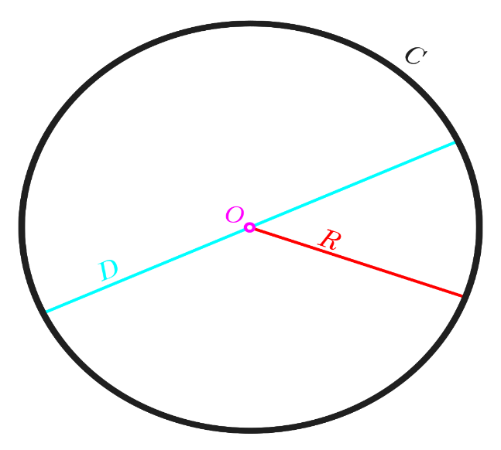
What is the mathematical name for the distance halfway across the circle?
What is the mathematical name for the point at the centre of the circle?

Rectangle challenge
Make five different sized rectangular shapes out of pegs, pencils or pens for example.
Measure the length and width of each and calculate its perimeter and then its area.
Remember:
Perimeter = length + length + width + width or length x 2 + width x 2
Area = length x width

