Maths Challenge

Can you sort some tins or packets of food into different sets?

Can you explain how you did it?

SSM78 43
Maths Challenge

Add up numbers on car registration plates. What are the highest and lowest totals you can find?
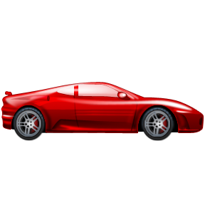

Practise writing these numbers at home. C68
44

Maths Challenge

Can you find 4 different sized spoons in your house and put them in order of size?
Can you use some pasta or a ruler to measure them?
SSM78 45
Maths Challenge

Draw your own pattern. ?
Can you describe it?

(It could be shapes or colours….)
What shape or colour did you use the most?
SSM46 46
Maths Challenge

Can you draw a repeating pattern using shapes?

Say the pattern out loud to yourself.
Can you create a pattern using your body?
Eg clap, clap, stomp.....

Now try a more tricky one...
SSM48 47
Maths Challenge

Can you find something that is hexagon shaped in your house?

Can you find something that is pentagon shaped in your house?

Can you find something that is octagon shaped in your house?

SSM68 48
Maths Challenge

Does it take longer to eat your breakfast or your dinner?

How did you work it out?

SSM8 49

Maths Challenge

Cut 6 different lengths of string and put in a bag.

Pull out 1 length and find one thing shorter and 1 thing longer?

Did you guess correctly the first time?
SSM78 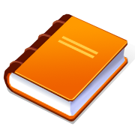 50
Maths Challenge

Look for tall buildings and short buildings?
Use ‘size language’ to describe what you see. (short, tall, long, wide, narrow)
Can you cut out some pictures of buildings and sort them by size?
SSM68 51

Maths Challenge

Ask a grown-up to draw you some snakes?
Which one is the longest? Which one is the shortest?
How can you find out?
Write down how long each one is.
Practise writing these numbers at home.

SSM68 52

Maths Challenge

You need a plastic jug and some different sized cups? (maybe a bath-time activity)

Guess how many cups of water will fill the jug?
Find out if you were right?
Were you right first time?
SSM78 53

1 2 3 4 5 6 7 8 9 10 1 2 3 4 5 6 7 8 9 10 1 2 3 4 5 6 7 8 9 10 1 2 3 4 5 6 7 8 9 10 1 2 3 4 5 6
Maths Challenge

How many jumps can you do in 1 minute?
How many numbers can you write in 1 minute?

Practise writing numbers 1 to 10 at home.

N678 54

Maths Challenge

Make a collection of different coins?

If you could keep 1 coin which one would you choose? Why?
Make some coin rubbings of your favourite coins
N8 55

Maths Challenge

What numbers can you see in your street?

Which is the smallest number? Which is the largest number?

Can you draw a picture of your street and write some of these numbers.
N589 56
Maths Challenge

What time do you wake up?
What time do you have lunch?
What time do you go to bed?

Talk about what happens in the morning, afternoon and evening.
SSM89 57

Maths Challenge

You need some pasta and another person to play.
Each take a handful of pasta. Who has the most?
Count to check.
How many more did they have?
C468 58
Maths Challenge

Ask a grown-up to write numbers 1 to 10 or 1 to 20 on small pieces of paper. Muddle them up.

How long does it take you to put them in order? Try again to see if you can be quicker.

1 2 3 4 5 6

N7 59

Maths Challenge
Make a number track snake game.
Divide the snake into 20 sections and label each section 1 to 20
Start at 10 with 2 counters. Spin a coin. If it lands heads move 1 space forward, if tails 1 space backwards. Can only move if the number is said correctly first.
Who will fall off the number track snake first?
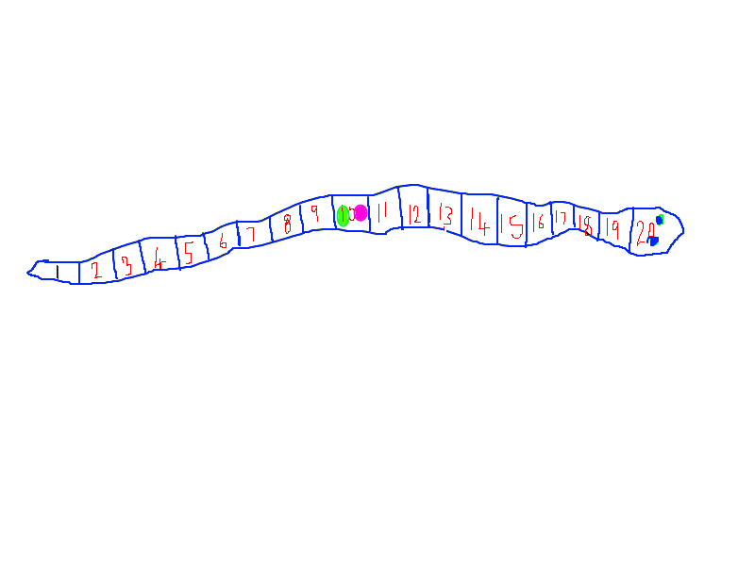
N68 60
Maths Challenge

Counting cars on a car journey or walking to school.
Choose a colour of cars to count. Who can be the first to spot (10) of their colour? Or how many can you count in 5 minutes.
Practise writing these numbers at home.  
N689 61

Maths Challenge
You need 10 toys and a blanket.
Count a number of the toys under the blanket. Eg 5
The grown-up will add a toy under the blanket and then ask ‘Now there is 1 more toy under the blanket. How many toys are there now?’ Encourage your child to count from 5, one more. Move blanket to check.
Choose another number of toys to put under the blanket. This time remove one. ‘There is 1 less toy under the blanket now. How many are left?’ Repeat this process and count on 2 more/less if 1 is easy.

C7 62
Maths Challenge

Make a food chart
Create a chart to record the fruit (or another food) your family eats for a week/month.
Count the number of pieces of each fruit eaten.
How many more of one kind of fruit were eaten than another?
What was the least favourite fruit?
N89 63

Maths Challenge

Estimate everything!! Then check to find out if you were right.
How many windows are in the car?
How many spoons in your drawer?
How many crisps in the packet?

Practise writing these numbers at home. C8 64

Maths Challenge

Out and about
Estimate how many strides is it to walk from point a to point b.
Check to see if you were right.

Practise writing these numbers at home. C8 65

Maths Challenge

Make up games with dice and playing cards.
Try rolling dice and adding or multiplying the numbers that come up.
Add up totals until you reach a total, like 20
Play the game backwards to practise subtraction.
Use cards to add to make specific totals eg which cards can you use to make a total of 8?
Practise writing these numbers at home. 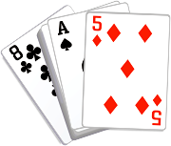C89 66

Maths Challenge

Guess my number?
I think of a number, then add 2.
The answer is 7.
What was my number?

Can you do some more.
C89 67

Maths Challenge

Problem solving
Some hens lay 2 eggs, 4 eggs and 3 eggs.
How many did they lay altogether?
Draw a quick picture to help work the answer out.
Think of some more problems to work out.
C689 68

Maths Challenge

How many socks are the members of your family wearing altogether?
Can you count them in 2’s?
Can you count forward and backwards in 2’s to 20?
Practise writing these numbers at home.
C689 69

Maths Challenge

Problem solving
In my pot there are 10 sweets.
Sally ate 3 and Ben ate 4.
How many are left?
Draw a number line to help work the answer out. 1 2 3 4 5 6 7 8 9 10
Think of some more problems to work out.
C689 70

Maths Challenge Cards
The maths challenge cards are short activity ideas that can fit into your day and will help your child see maths as fun. The cards relate to the different strands of the area of learning called ‘Problem Solving, Reasoning and Numeracy.’
N =Numbers for Labels and Counting
C = Calculating
SSM = Shape, Space and Measures
You can repeat each activity as many times as your child wants to. Feel free to change the ideas to suit your child’s interests, what you have in your house and their current level of development. If your child wants to represent their thinking on paper let them do so in their own way. For example they might not want to write numbers, but they might want to draw to communicate their mathematical thinking.
We encourage you to share any ideas you have for maths challenges so that our collection of cards can grow and we can learn from one another.

