Little Red Riding Hood

Once upon a time, there was a girl called Little Red Riding Hood. She lived with her mother in a village near a forest. One day, Little Red Riding Hood wanted to visit her grandmother. Her mother warned her not to talk to any strangers.
On her way, Little Red Riding Hood met a wolf who asked where she was going. “I’m going to visit my grandmother who lives in the forest,” said Little Red Riding Hood. The wolf ran to her grandmother’s house and locked Granny in the wardrobe! He put on her nightgown and got into her bed.
When Little Red Riding Hood came to the house she said, “Oh Granny, what big ears you have.” “All the better to hear you with,” answered the wolf. “Oh Granny, what big eyes you have,” said Little Red Riding Hood. “All the better to see you with,” replied the wolf. “Oh Granny, what big teeth you have,” gasped Little Red Riding Hood. “All the better to eat you with!” replied the wolf. Little Red Riding Hood saw it was a wolf and shouted, “Help!”
A nearby woodcutter heard Little Red Riding Hood’s scream and ran to the house. The woodcutter hit the wolf and let Granny out of the wardrobe. The wolf ran away and they never saw him again.

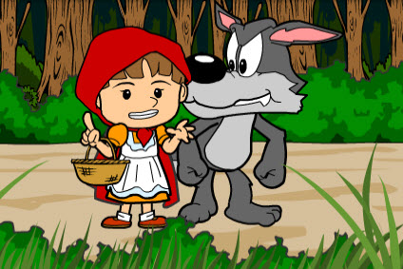

Can I answer the questions about Little Red Riding Hood?

1. Who else was in the story with Little Red Riding Hood?

2. Where was Little Red Riding Hood going?

3. What did the wolf ask Little Red Riding Hood?

4. What did the wolf do with Granny?

5. What did the wolf do to make himself look like Granny?

6. How did Granny look different when Little Red Riding Hood got there?

7. What did Little Red Riding Hood shout when she saw it was the wolf in bed?

8. Who saved Little Red Riding Hood and let Granny out of the wardrobe?

9. What do you think Little Red Riding Hood should not have done at the beginning?

