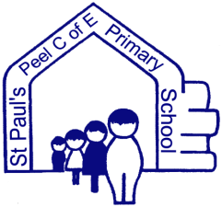
Websites to access for Home Learning
https://www.stpaulspeellh.co.uk/page/spring-term-2020-curriculum/64167
This page on the school website will tell you the work that is taking place in all classes this half term (Spring Term 2 2020)
www.PhonicsPlay.co.uk
This website is full of lots of phonic activities.
www.monsterphonics.com
This website is full of phonic games and songs.
www.spag.com
This website allows Year 2 – Year 6 pupils access to spelling, punctuation and grammar activities. The pupils have their own usernames and passwords.
www.linguascope.com
This website allows Year 3 – Year 6 pupils to learn French.
www.ttrockstars.com
This website allows pupils to learn their times tables. The pupils have their own usernames and passwords.
www.play.numbots.com
This website allows pupils to learn their number bonds. The pupils have their own usernames and passwords.
www.mymaths.co.uk
This website allows pupils to complete maths activities. The pupils have their own usernames and passwords.

www.discoveryeducation.c.uk
This websites covers the whole curriculum from Nursery – Year 6.
www.online.espresso.co.uk
This website allows pupils to ‘code’.
www.twinkle.co.uk/offer
This website allows parents/carers to access activities across the whole curriculum.
Password: UKTWINKLHELPS

