**Play Streets is back in Little Hulton for Summer. Take part in FREE activities for 5-11’s (under 8’s must be accompanied by a parent or guardian)**

**Mondays 1pm-3pm 29 July, 5 Aug,12 Aug, 19 Aug at Peel Park Pavillion, Manchester Road W**

**Tuesdays 12pm-2pm 30 July, 6 Aug, 13 Aug, 20 Aug, 27 Aug at Kenyon TARA, 14 Hallstead Ave**

**Wednesdays 10am-12pm 7 Aug, 14 Aug, 21 Aug at Old Lane Resource Centre, 130 Old Lane**

**Thursdays 1pm-3pm 1 Aug, 8 Aug, 15 Aug, 22 Aug, 29 Aug at West Children’s Centre, Longshaw Drive. There will also be Play Tots sessions the same times Thursdays for under 5 siblings & parents.**

**Fridays 1.30-3.30pm 2 Aug, 9 Aug, 16 Aug, 23 Aug, 30 Aug at Bridgewater Youth Club, 72 Bridgewater Street.**

**FREE pack lunches will be provided at all sessions.**

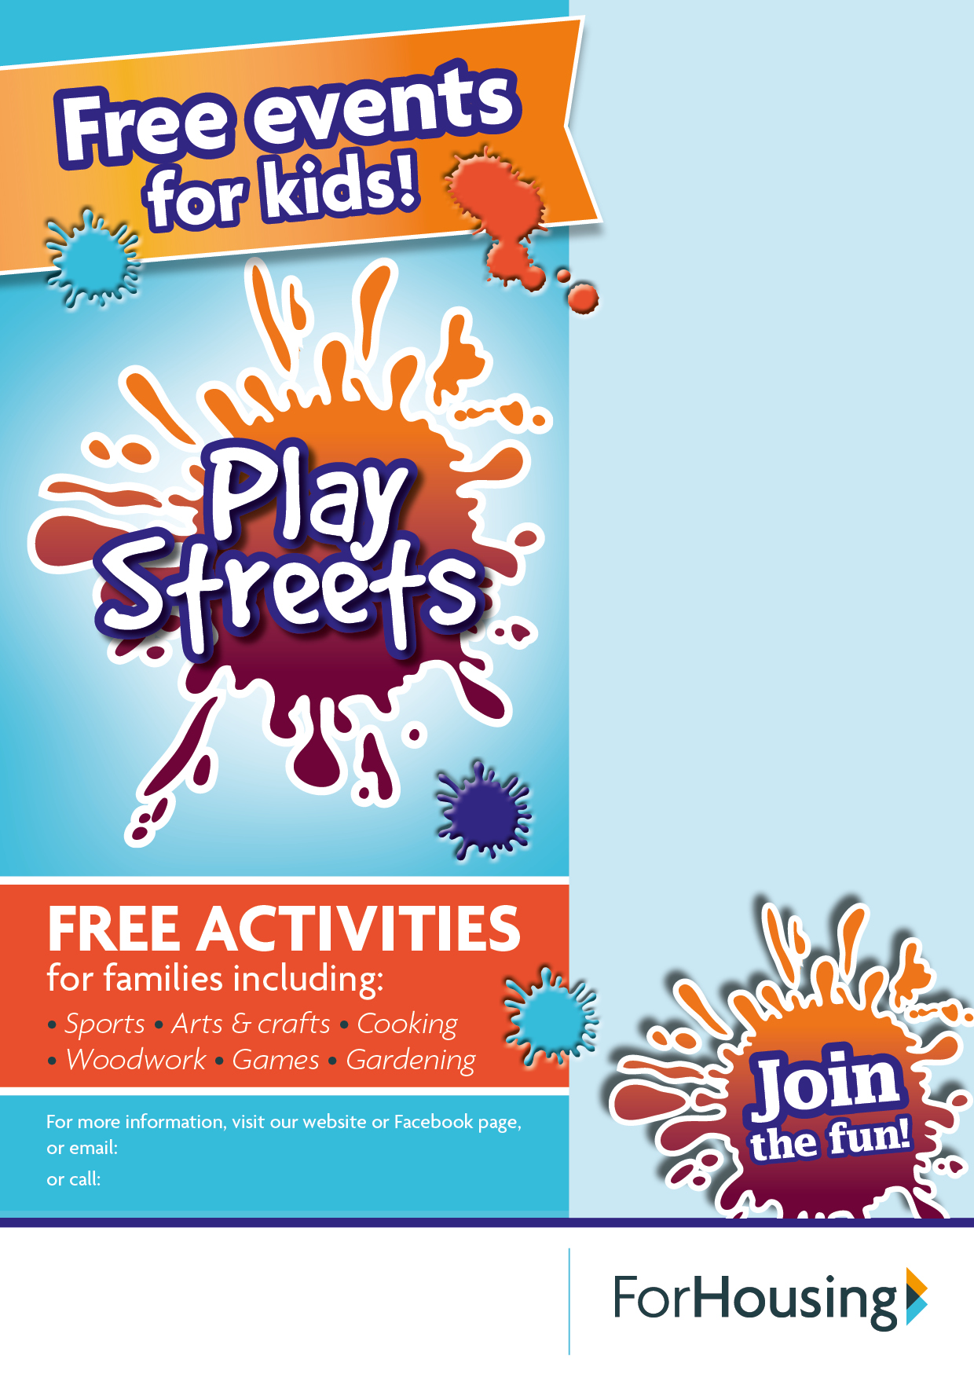

**Natalie.Stokes@forhousing.co.uk**

**0161 611 7315**

